PROJECT REPORT ON

**Music Streaming APPLICATION-V2**

SUBMITTED BY: **22f1001972@ds.study.iitm.ac.in**

NAME :- Imran Ashraf

ROLL NUMBER **:- 22f1001972**

This Music Streaming App is a feature-rich platform designed for music enthusiasts. It accommodates both general users and creators, with the ability to stream music and read song lyrics. Users can enjoy music, view lyrics, rate songs, and curate their playlists. Creators, on the other hand, have the privilege to add new songs, albums, and lyrics.

**TOOLS USED IN THIS APPLICATION**

1. Backend Programming Language and Web Framework
   * Python: Used for developing the backend logic and handling server side operations.
   * Flask: Used for building the application’s backend, routing, Restful API ,and handling HTTP requests.
2. Frontend Programming Language and Web Framework
   * JavaScript : Used for developing the frontend logic and handling client side operations.
   * VueJS - Used for User Interface
3. Database Management-
   * Flask SQLAlchemy (SQLite) : Serverless relational database management system used for storing application data.
4. Backend Development-
   * + Flask Restful API - Used to develop the RESTful API for the app
     + Use Flask Security based Token Based Authentication
       - User/ Creator signup and login (using RBAC)
       - Admin Login (using RBAC)
       - Song/ Playlist / Album Management
     + Backend Performance (BY Flask Cache)
       - Used for caching API outputs and increasing performance.
     + Backend Jobs (Asynchronous background jobs at the backend)
       - Redis and Flask Celery
       - Daily Reminder on Email/ Google Chat
       - Monthly Activity Report for each creator on Email
5. Frontend Development-

* HTML: Used for structuring the content and layout of web pages.
* CSS: Used for designing the visual appearance of web pages.
* Bootstrap - Used for HTML and CSS styling
* VueJS - Used for User Interface

**FUNCTIONALITY**

1. Admin Dashboard: The admin has a dedicated dashboard to monitor app statistics, user/creator counts,songs performance, and the ability to manage content that breaches guidelines.
2. User and Creator Profiles: General users can manage their playlists, while creators enjoy advanced privileges to create and edit songs, lyrics, and albums.
3. Search Functionality: Users can search for songs and albums based on various criteria such as song name, album name, genre name and artist name.
4. Validation: Robust backend validation ensures data integrity, with appropriate error messages to guide users.

**KEY FEATURES :-**

1. Multi-User Support: The app caters to different user roles, including a required admin and general users who can also register as creators.
2. Music Streaming: Users can listen to music, read lyrics, and rate songs, creating an immersive musical experience.
3. Song and Album Management: Every song and album is uniquely identified, with detailed attributes like name, lyrics, duration, and date of creation.
4. Playlist Creation: Users can assemble their playlists by adding one or more songs.
5. Albums with Multiple Songs: Each album can contain a varying number of songs, making it easy to organize music collections.
6. Dynamic Content: The app showcases the latest music additions and popular tracks, ensuring a fresh and engaging experience.

**ER-DIAGRAM OF THE MODELS CREATED :-**

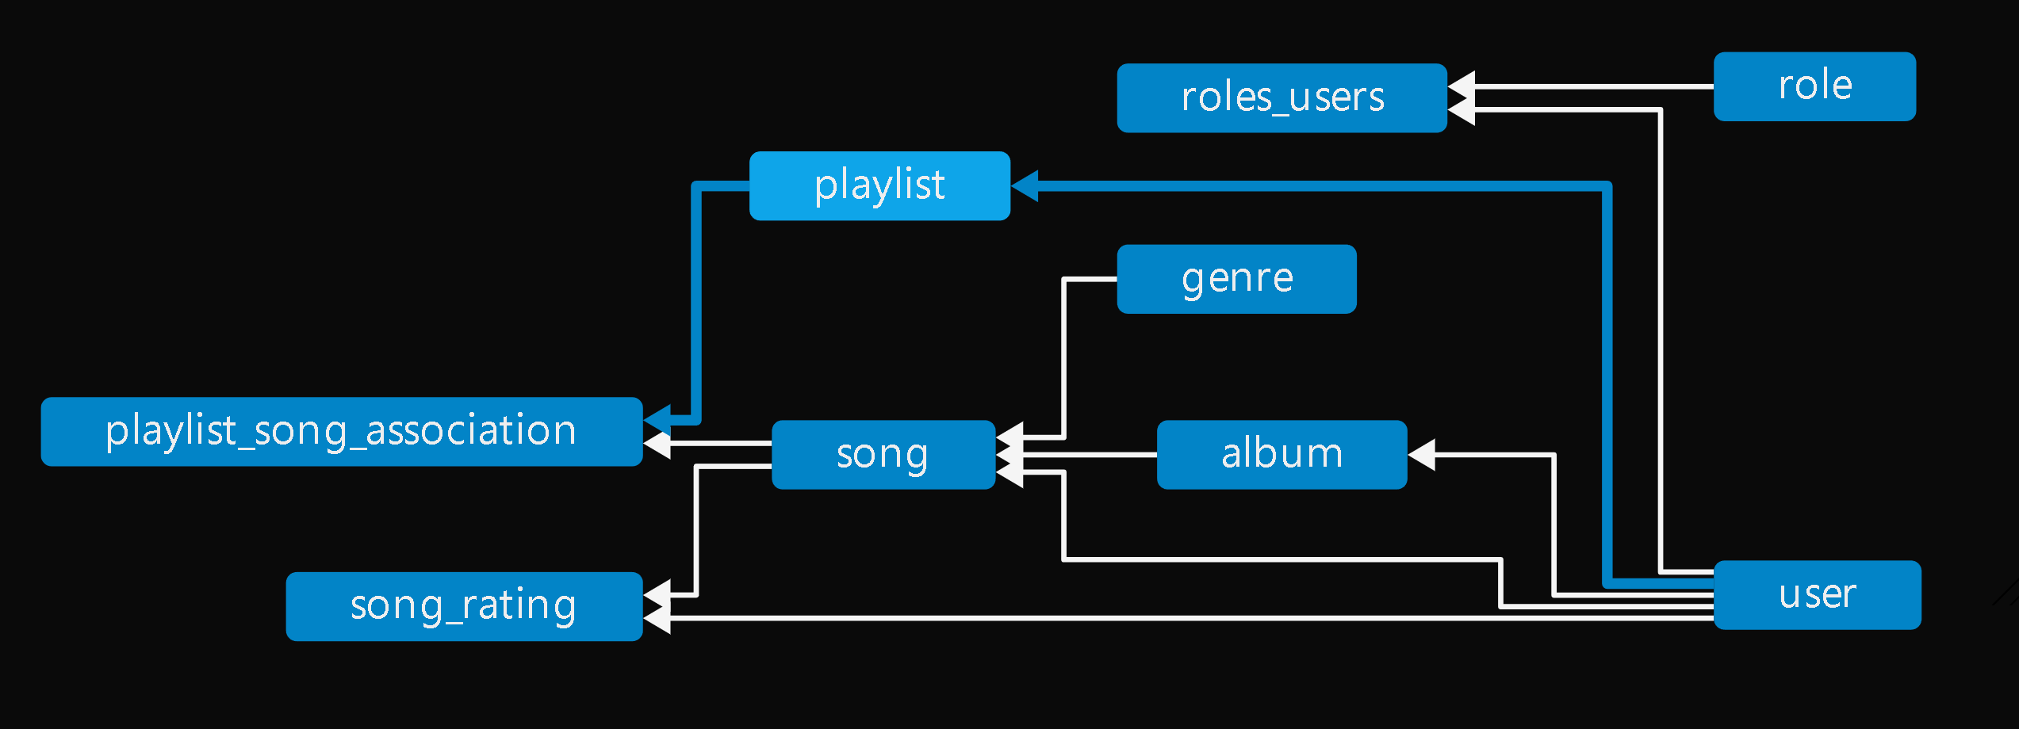

**VIDEO LINK :-**